Create Your Own Government Project
Congratulations! You have started your own sovereign nation. Before you can really get down to business, you need to decide how your state will be organized. In this assignment, you will create a brochure describing your new government to your citizens. Be sure to make your brochure neat, detailed, and attractive – You should make your people want to live in your country! Good luck!

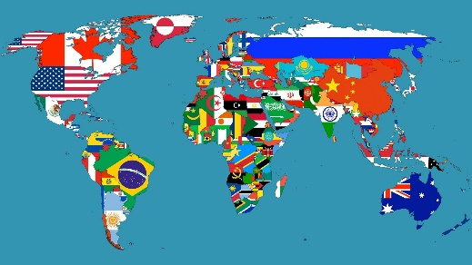
Forms (types) of Government to Choose From
Oligarchy
Autocracy (Dictatorship, Monarchy)
Direct Democracy
Representative Democracy (Parliamentary or Presidential)
Theocracy

Government Systems (structures) to choose from
Unitary
Federal
Confederal
Parliamentary

Economic Systems (structures) to choose from
Traditional economy
Market economy
Command economy

Brochure
You will create a brochure. On this brochure you must include the following:
*The name of your country
*The country’s flag and explanation for its design
* A map of your country’s shape along with a key (symbols) that represents what is produced in your country
*What form of government your country has

*The system (structure) of government (Examples: You may choose Direct democracy as your type with a confederal system. This would mean that all individuals ae directly involved with making laws from the region they live in and there is no little or no power in the central government. Another example might be a Theocracy with a Parliamentary system (structure). This would mean that your country bases its laws on a religious doctrine, and makes decisions with a combined executive/legislative body)

*The definition of your government type and structure (system)
*List 5 characteristics of your government type
- How do leaders become leaders?
- Who makes the decisions in the government?
- Who holds power in this form of government?
- How are the people’s views taken into account?
- How does the government raise money?
*The definition of your economic system
- How does the system meet the needs of your people
- What are the main goods that are produced by your country
*What is one benefit (pro) of your country’s government?
*What is one drawback (con) of your country’s government?
*Name a country in the world that has your form or system (structure) of government.

*Make your brochure look creative, organized, and neat!

Create Your Own Government Grading
Group Members ____________________________________________________________ Per _________

1. Country name | 0-No name |  | 1- Name listed
Our Flag and its Meaning
2. Flag | 0-No flag and/or description | 1- Average flag and description | 2- Creative flag and description
Our Government Type & System
3. Type (form) and system of government | 0- Not on | 1- Type or Structure only | 2- Both a type and a structure listed on brochure
4. Definition | 0 – No definition or incorrect | 1 – Some of the definition is correct | 2 – Correct, detailed definition
5. How do leaders become leaders? | 0 – Not listed or incorrect | 1 – Listed with few details | 2- Detailed description
6. Who makes the decisions in the government? | 0 – Not listed or incorrect | 1 – Listed with few details | 2- Detailed description
7. Who holds power in this form of government? | 0 – Not listed or incorrect | 1 – Listed with few details | 2- Detailed description
8. How are the people’s views taken into account? | 0 – Not listed or incorrect | 1 – Listed with few details | 2- Detailed description
9. How does the government raise money? | 0 – Not listed or incorrect | 1 – Listed with few details | 2- Detailed description
Pros & Cons of our system
10. What is one benefit of your country’s government? | 0 – None or incorrect | 1 – Listed with few details | 2- Detailed description
11. What is one drawback of your county’s government? | 0 – None or incorrect | 1 – Listed with few details | 2- Detailed description
Our Economic System
12. Map with key (symbols) to show what is produced in your country | 0 – No map | 1 – Map with no key or incomplete and hard to understand | 2- Map and key is easy to understand
13. Definition of the economic system you chose. | 0 – Not listed or incorrect | 1 – Some of the definition is correct | 2 – Correct, detailed definition
14. How are the needs of the people met and what are the main goods produced? | 0 – Not listed or incorrect | 1 – Listed with few details | 2- Detailed description
Countries around the world
15. Name 1 or more countries in the world that has your type or system of government. | 0 – None or incorrect |  | 1- Correctly listed
16. Overall (creative, organized, neat, and polished) | 0 – Incomplete, no color, done in pencil, missing sections | 1 – Mostly complete, with color, some white space on the page | 2 – Complete, colorful, neat, organized
Points for team members individual effort | 0-3 very little contributed effort | 4-7 contributed more, but not fully engaged | 8 contributed a satisfactory amount (fully engaged)

Home group assessment- ___________/30 points Alternate group assessment- _________/30
Points that you believe each of you earned due to your individual effort (max value 8 pts for each individual)

Student Names - _________________ ____________________ _________________ __________________

Points for effort-

Total points /38 /38 /38

/38

